





®



Issue No 22 Autumn 2018

Anglican Cursillo® in the Diocese of Oxford www.OxfordCursillo.co.uk

Affiliated with the British Anglican Cursillo® Council Reg US Patent Office Registered  Charity  No. 1117925

**CONTENTS**

Page

National President 2,3

National Ultreya 4 Oxford#18 5,6,7

Street Ministry 8,9

Page

Editor’s Interview:

Jan Jeffreys 10,11,12

A visit to India 13,14,15

Dates for your diary 16

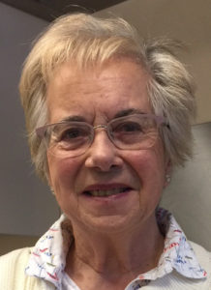

*Welcome to the 2018 autumn issue. I hope you will be inspired reading about a street ministry and an article about helping destitute children*

*in India. Our Cursillo Weekend at Cold Ash is featured, with two new Cursillistas sharing their experiences. My Editor’s Interview this time is with Jan Jeffreys, who will lead our next Cursillo Weekend in spring 2019.*

*Send articles and ideas to me at* [***magazine.editor@oxford***](mailto:magazine.editor@oxford)***cursillo.co.uk***

*Deadline for the spring issue is* ***March 15*** *for publication in April.*

*Vivien Leeming, Editor*

**Message from our National President, Trevor King**

**“Here I am Lord, again!”**

****I’ve just got back home from another wonderful National Ultreya weekend, this time at Chelmsford, Essex. (A huge ‘thank you’ to everyone in Chelmsford Cursillo who helped put it on, well done). I haven’t been to all the Nationals since I made my Cursillo 26 years ago, but every one that I have been to has been an uplifting, memorable occasion. But none more so than the first one I went to in Southwell Minster back in 1992, just 6 months after I’d been on Chester #10.

It was there that I heard and sang for the first time our unofficial Cursillo anthem, ‘Here I am Lord, is it I Lord’. We didn’t use it at our church back then and we hadn’t sung it during my Cursillo weekend so I was unfamiliar with it. Those of you who know me will vouch that I love a good sing and I can pick up a new tune quickly so I had no trouble singing it lustily by the second verse. But as I was belting out the chorus my late wife started digging me in the ribs. I looked at her and she said, “Have you actually read those words? If you really mean them think of the implications!”

Would I go if He led me? Was I prepared to hold His people in my heart, whoever they were? I believed the answers were ‘Yes’ so I sang on.

The message of my Cursillo weekend had really hit home: that if I really believed Christ had died to save ME, to pay the price for my sin, my unworthiness, then the least I could do was to find some way to serve him through the rest of my life. I had begun trying to work out what that might mean but I hadn’t got very far. The words of the hymn suddenly made it clear to me. I had to be prepared to literally go, to up-sticks from our cosy life in Cheshire and serve Him anywhere.

Over the next five years or so we looked at many possibilities; as both my wife and I were trained in catering management we focused on that area, applying for jobs at diocesan retreat houses for example. I remember going for interviews at Pleshey Retreat House in Chelmsford Diocese, Morley Retreat House in Derbyshire and Whirlow Grange in Sheffield, all unsuccessfully! We offered ourselves to Wycliffe Bible Translators who needed a couple to run a guest house for them in Cameroon, Africa, but they turned us down. We were successful in getting jobs with a Christian outward bound activity centre at Harlech in North Wales but that all went wrong after 3 months and we were back at square one.

So I kept searching and finally the Lord led me to move my family up to Scarborough. I had a job with the main parish church setting up a Social Action Centre for those many folk living in B&B accommodation or worse in the town. I was overjoyed that I’d found the role in which I could use my organising and fund raising skills and experience to further His kingdom, and I loved every minute of my time there.

Things move on though, circumstances change and after nine years I developed work related stress and depression and had to leave. What was going on? I thought this was where you wanted me Lord, I prayed (shouted actually, more than once!). How was I going to be able to serve Him now? Thankfully I quickly found another job but it had nothing to do with the church, it was bus driving. How was this serving Him?

It wasn’t long though before I started to realise that what I was doing in my secular job was a form of service to God. I was driving the most precious of passengers, young children, to and from school and I was quickly dubbed the cheerful bus driver (not all of them are). My passengers during the day on the seafront were largely older folk and I could cheer them up and have a laugh with them, hopefully improving their day. And my elderly parents, who had moved to Scarborough, started to need more help and care which built up to almost daily visiting. This, then, was to be my service for a few years.

Fortunately I was able to take early retirement so I could once again offer myself to the Lord. ‘Here I am Lord, what do you want me to do now?’ I had already become more active in York Cursillo and had been asked to be the next Lay Director. Then we took on organising the 2016 National Ultreya. My own parish church had been struggling with the problem of replacing the aging church hall but plans hadn’t got very far so I offered to take it on as volunteer Project Manager. (We now know exactly what we want to do, have all the permissions we need, and have raised over £100,000 so far. Still a long way to go but we’ll get there.)

And then I was asked to take on this role of Anglican Cursillo National President!

Looking back over the last 26 years since I first offered my service to the Lord I can now see that I have needed to say ‘Here I am Lord’ many times as life circumstances have changed. I’ve had to be prepared to look around and be open to new opportunities and challenges as God chooses to give me new things to do, to ‘go’ where He sends me. I don’t claim to have been obedient all the time, to have understood what was happening all the time, to have succeeded or got it right all the time, but in my weakness I have tried. Please pray for me as I continue to try to serve Him and pray that in future years, after I’ve finished being President and our new church hall has been built, I’ll still be able to say ‘Here I am Lord, what do you want me to do next?’. I urge you to do the same.

ULTREYA!

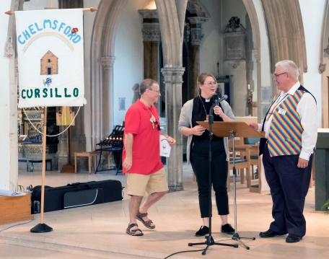 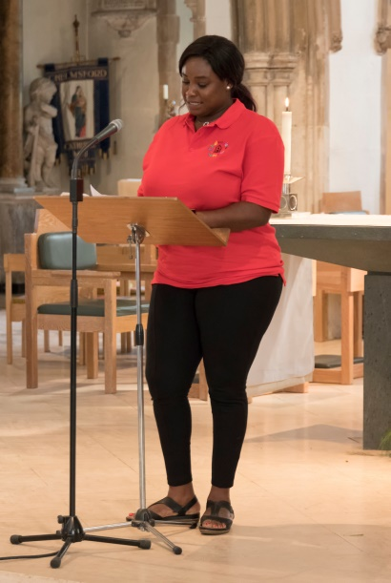 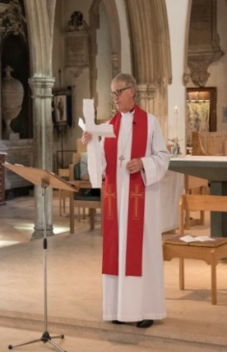 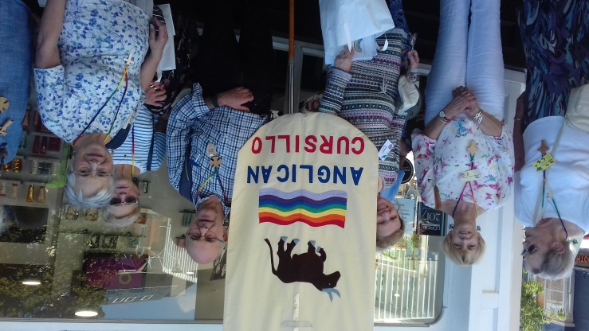 *Photos by Kevin Blow and Jan Jeffreys*

Chelmsford Cathedral was packed with over 300 Cursillistas from all over Britain, including 14 from Oxford Diocese, for a lively and inspiring National Ultreya in September. Microphone in hand, it was compered in an informal style by the Rev. Alexandra Guest, and we sang our songs of praise to the Lord accompanied by a rock band which lifted the rafters.

Inspiring testimonies and a witness talk were given by the speakers, following an introductory talk by our national president Trevor King, as usual wearing his flamboyant striped waistcoat!

A floating Ultreya encouraged us to group with people we did not know from other parts of the country,

After lunch, which for many of us meant a picnic in the cathedral or outside in the sunshine, we processed our banners through the town back to the cathedral for the Clausura Eucharist conducted by the Bishop of Barking, the Right Revd Peter Hill, who, in his address got us all tackling the art of origami! *See photo, right.*

NATIONAL ULTREYA

AT CHELMSFORD

Uplifting, inspiring and fun!

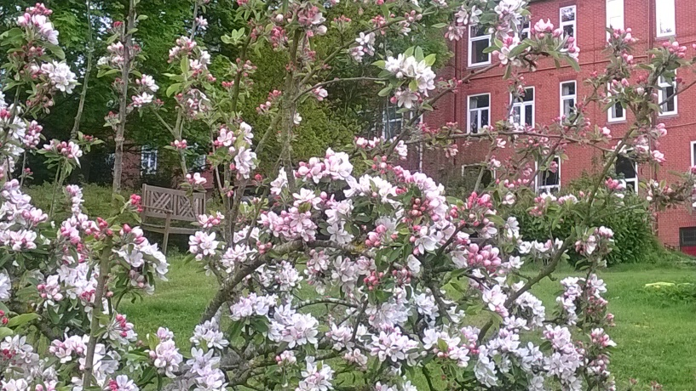**Oxford#18**

**St Gabriel’s Convent and Retreat Centre at Cold Ash,** **near Newbury, provided a beautiful and peaceful setting for our 3-day Cursillo Weekend in April.**

**Two new Cursillistas give us some of their impressions.**

Reflections

*By Jackie Holderness, Education Officer at Christ Church Cathedral*

I first heard about Cursillo several years ago from Bishop John Pritchard, during a visit to the Holy Land, and was very interested in the Cursillo notion of empowering the laity and distributing faith leadership, which is important to achieve God’s work on earth. Having lived through three interregnums in my local parish, when the laity had to empower themselves to sustain the teaching, worship, pastoral and mission work, I have become a firm believer in the idea that God draws together all people, whatever their background, skills and talents, to serve him wherever they live and work.

When I arrived at Cold Ash on the Thursday evening, not knowing what to expect, I was very moved to see and hear that other Cursillistas around the country were praying for the twelve new Cursillistas from our diocese. A display of zigzag cut-out people, holding hands, served as a daily reminder that God’s kingdom works best when we realise we are all interlinked and that our prayers across distance and time can bear much fruit.

When we were offered the fruit of the vine in a glass as a welcome drink, I was reassured that this weekend was not going to involve too much privation and soon came to realise that the goal was to celebrate God’s great goodness and plenty. The three-day weekend was a living reminder as to how we should care one for another and share God’s great love. The concept of Palanca was shared with us many times; through the encouraging emails in advance and since; through the bedtime surprises; the bags of cards and little gifts; the gifts of music and witness; the final party; and then the appearance of our sponsors at the final service. All these acts of care and kindness added up to each person there feeling valued and loved, which is how God wants us to feel. Christ was and is the servant King, and the emphasis on willingness to serve and on action through small and simple acts of kindness was something I found particularly memorable.

But, of course, the weekend offered a great deal more than warmth and kindness. The three core concepts of Cursillo are Piety and Prayer, Study and Action. We were privileged to have as our lay Director, Johanna Raffan, whose marvellous sense of humour and gentle but determined ability to stick to schedule kept the weekend running smoothly. Our talented and ever-cheerful resident musician, Sally Mears, accompanied our daily hymns and led us in grace each meal, while spiritual direction was thoughtfully and inspiringly provided by priests Kevin Beer and Tony Price.

We started each day with a service, gathering in the Sisters’ guest chapel, where we could hear the birds and breeze in the trees outside as we enjoyed the silence before the first hymn. Each day we had a service where Tony or Kevin officiated and gave a short talk. As someone fascinated by the power of narrative, it was good to discover that Tony is a gifted biblical storyteller.

I very much enjoyed the worship. In its simplicity, community and use of song, it reminded me a little of Taizé, in France, whose ecumenical community of brothers has inspired Taizé forms of worship around the world. Interestingly, both Taizé and Cursillo model their learning and teaching on Easter week. The Cursillo weekend brings the cross to the fore, and encourages us, especially on the second evening, to feel more deeply the enormity of Jesus’ sacrifice, before we celebrate the light and joy of His resurrection, on the Sunday.

The hard-working team of table helpers and ‘gofors’ were wonderfully supportive and we all got to know each other very well, thanks to the various tasks we were given. For some people, these stretched our limited artistic capabilities, but we soon realized that the quality of the task outcomes was less significant than the camaraderie they had fostered- and the laughter that often resulted! One enduring memory I have is of Dorothy, one of my fellow guests, dressed as a bishop and wearing a cardboard mitre, in a mime we had devised to share our ideas with the others. Somehow, we managed to fulfil every task and, even when acting, to keep (but only just) a straight face!

Of course, the tasks were deliberately framed to be a light-hearted way to discuss key themes and to reflect upon the issues raised by each of the talks. Each talk was simply told and was memorable and remarkable in that it showed how each individual can serve as a prism for God’s light in the world. There is something very powerful about the sharing of personal witness and the providing of examples of the many little ways we can contribute to God’s kingdom, through service, action, piety, study and love.

I am sure that the new Cursillistas left Cold Ash feeling loved and feeling love for the team of sponsors, strangers, leaders, helpers and each other. As I drove away on the Sunday evening, my heart was full, with an increased awareness of God’s love for each one of us and His desire that we love one another. I am certain that God would very much approve of groups of twelve coming together to learn how to become better disciples.

The weekend is designed to help us to acknowledge God’s presence, read his word, learn from others how to make a difference and how to establish God’s kingdom on earth. The challenge, of course, is to be able to sustain the very special qualities of a Cursillo weekend and implement what we have been inspired and challenged to do, once we have returned to our busy, often challenging lives.

Managing to meet with other Cursillistas has been very helpful. Three of us have agreed to meet once per month inside Christ Church Cathedral, to support one another. Others would be welcome. The Ultreya meetings are also very valuable. So far, I have only been able to attend one of them, but it was good to see some familiar faces, meet new ones, and to worship together.

Another opportunity to meet up with people will be the Oxford AGM on October 27th, in Cumnor, at the URC hall. 10.30 am for 11am start. Till then, **Ultreya!**

The weekend was a chance for God to make me listen!

When I was invited on a Cursillo weekend I tried to find excuses not to go.  I was too busy.  I was only being asked as they needed to fill the space.  How could I justify having 3 nights away from home and not doing any chores etc?

However, God spoke to me and said: “How else am I going to get your attention unless I pick you up from your busy life and place you in Cold Ash where you are going to have to listen to me!”

So off I went on the weekend.  It was four days of listening to people talk about God, their faith, their journeys.  My table group was amazing.  Although we had all been chosen by people who did not know us all we were on the “right” table.  My group all contributed to the discussions and their words helped me and my faith to grow that little bit more.  It challenged us all as to what our next stage in our Christian life could be.  That challenge is still open for discussion with God as to where He wants to lead me.  But for now, He wants my time and to nourish me with His word - to rest awhile in His presence.

Sometimes after a talk, instead of the usual discussion, it was suggested we do some artwork which is not something I normally do, it just does not appeal to me. However, one evening alone in my room overlooking the hills I sat and drew in my prayer book.  A picture of a vase came to mind so I drew it close to the top of the page.  It was empty and there was no space to add flowers or a jug to pour water into the vase so the flowers would not die.  This is what I was like before the weekend.  I was tired.  I was empty.  In my life I did so much for God and yet had no time for Him to talk to me.  God took me away so He could fill me again - with His living water - to give me His peace.

The Palanca was overwhelming - people from faraway places sending words of encouragement and love to us.  The phrase “brothers and sisters in Christ” meant something real.  I was part of a larger family who only knew my name and yet could send me quotes and pictures which gave inspiration and reassurance of God’s permanent love for us.

Saturday arrived and our evening dinner was like the party in Heaven where we were spoilt with care and attention and made to feel special and loved.  God’s love shone through to me through everyone I met.

Some of us found the weekend was like going up a mountain to see Jesus.  We could not remain up there in isolation from the world or build a tent to hide away.  We had to return to our homes in our villages and towns. So what now, after coming down the mountain and back to the reality of our busy lives?  I try to find more time for just me and God.  I try to read more about Him and to spend time reading the Bible.  It does not happen as much as I would like but I am happy not to be running around all the time and to know I can sit, read and pray without feeling guilty.

It was definitely the right decision to attend the weekend and I give thanks to Peter whom I now call persistent Peter for not letting me say no!

Finally, I would like to thank all the people who organised and ran the Weekend, and all the many helpers. You did a marvellous job*.*

***Karen***

Lollipops and flip flops are part

of a street pastor’s kit!

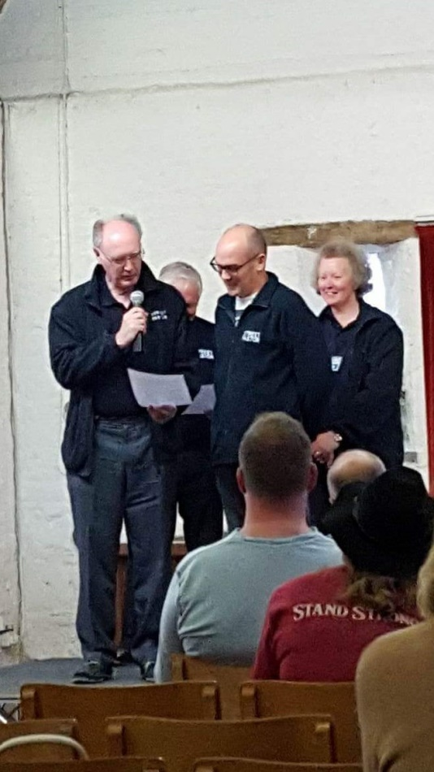

STREET PASTORS is a national movement that is 15 years old. It comes under the umbrella of the charity, Ascension Trust (which is celebrating 25 years of equipping to serve).

It involves teams of Christian volunteers going out on the streets late at night (typically from 9.45pm to 2.30am) to support people in our communities who may be having difficulties. Sometimes we listen to restaurant owners whose businesses are not flourishing, occasionally to people who are suicidal or homeless, to the lonely or to those who just want a friendly chat.

*Sally at her commissioning service*

*Sally Mears describes her involvement with a*

*late-night ministry in Abingdon*

We do offer to pray for those who want it for themselves or for relatives who are ill, or an important event coming up in their own lives. Mostly we offer practical help by handing out bottles of water, flip-flops (for girls in high heels when their feet are in agony), space blankets to keep them warm, and lollipops - the glucose helps reduce the effects of alcohol and is a useful opening conversation gambit. It is hard to argue or fight while sucking a lolly!

Street Pastors do not preach to people but, hopefully, show God's love and grace by practical deeds such as helping someone get a taxi or the bus home or by collecting beer bottles and clearing up broken glass.

We are not allowed to give First Aid, but of course, we can call an ambulance if necessary.

In 2010, the Church in Abingdon representing 14 churches of all denominations, was asked by the police to set up Street Pastors there after they had found that having Street Pastors in Wantage had significantly lowered rates of antisocial behaviour and petty crime.

Eight days of training is required (which took me a year to complete). This includes at least four sessions going out wearing a hi-vis jacket instead of the movement’s sober dark blue uniform.  Of course, the public directed their questions at me as they didn't see it said "observer" on the back! All Street Pastors have to be at least 18, but I know one lady who is 87 years old!

I chose to do this after attending a Cursillo course in April 2016 (Oxford #17) as one of my table leaders, Mr N. Hance, spoke about his experience as a Street Pastor in Wantage and how God guided his conversation with the first young person he spoke to about the inventor of TV, who happened to be this person's grandfather.  The very same story was printed in The Door, our Diocesan newspaper, so I thought maybe, just maybe, this was something I should investigate.  I am a night owl anyway! And I enjoy getting to know people.

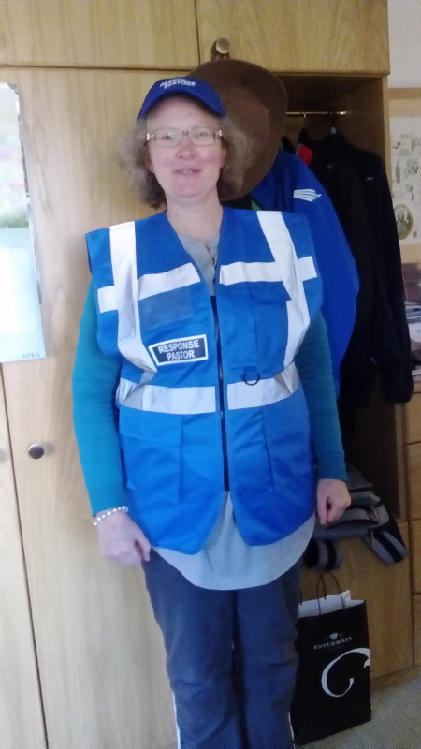We go out in teams of 3 or 4 but back at base there are two prayer pastors till just after midnight  who pray for us, the town and all households, and  particularly for those people who struggle to sleep. These prayer pastors are absolutely essential!

Times of uncertainty provide an environment for conversation around the big issues of life, and indeed, times of far greater openness to the Gospel.  God does have a sense of humour and I don't think people remember much of their conversations in the morning! (We once met an alleged Satanist who shamefacedly said his name was "Christian"!)  The early Church had a good prayer for great boldness when faced with opposition - see Acts 4: 29 - 30.

Wonderfully, God has promised that we are not on our own. It is a relief to know that it is not up to us and that God does not leave us destitute but has sent his Holy Spirit to inspire our prayers, give us wisdom and reveal to us the right things to do and say, whatever situations we find ourselves in.

Please consider joining a team of Street Pastors in your locality and please remember us in your prayers.  ULTREYA!

Cursillo is a movement of the Church providing a method by which

Christians are empowered to grow

through prayer, study and action

and enabled to share God’s love

with everyone.

**Editor’s Interview: JAN JEFFREYS, of Kidlington, who will be Lay Director at Oxford#19 at Cold Ash near Newbury next May**

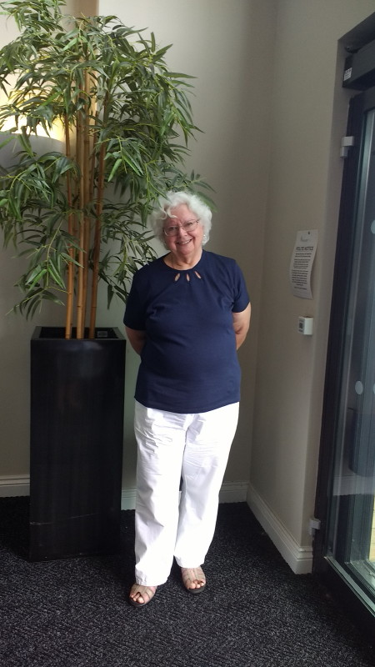

A God of

surprises

Jan has found her Christian commitment has led her along many paths including caring for homeless men

**Question:** *Jan, have you always been a Christian?*

**Answer:** Yes**,** I grew up in a Christian household, went to Sunday school and became a Sunday School teacher before going off to do my nursing training. I had vague thoughts about becoming a nun. However a man appeared on the scene. Peter was a Christian, too. We married and had two children, and 54 years on we are still happily together. But I realised that as a “cradle” Christian it is rather easy to take it all for granted, and I rather envied people who came to it later in life and had a “Born Again” experience.

Q: *When and where did you make your Cursillo Weekend, and what effect did it have on you?*

A: My Weekend was in 2002 at Wychcroft House in Surrey while we were living in Hove, in the Chichester Diocese. It was an amazing weekend and I was chosen to sum up the experience for my decuria and I remember saying that as a group we felt we had been loved, forgiven and restored.

I find Group Reunion makes me more aware of how I choose to live my life, keeps me on my toes about what I read and watch, and on the lookout for those special moments when one feels especially close to Christ. It also makes me more observant of the world around me, things and people. It can bring wonderful friendships which deepen over time and become really supportive in both good and bad times in life. I suppose I would say it enriches my life.

**Q:** *Tell us about your nursing career.*

**A:** I was a night sister in a neurosurgical/neurological hospital in Haywards Heath for 13 years. This came to an abrupt end when my mother and my best friend and colleague died within a few weeks of each other. This was dreadfully hard and I missed them both. My friend worked with me at the hospital and somehow the work lost its savour without her and the laughter and rapport we shared. I decided to resign and take some time out. After this I did a variety of jobs, all within the NHS. After some years I became a practice nurse at a GP surgery in Lancing, a job I loved and stayed in for 14 years until I retired to work with the homeless.

**Q:** *What did your voluntary work for homeless men involve?*

**A:** Peter and I were members of a church in Hove that ran a night shelter for homeless men, which was also supported by a community of monks and nuns. Once a week as part of a team we cooked a meal in our home for up to 16 men and took it by car to the church as there were no facilities there. It was a busy and eventful time in our lives. The night shelter had a great atmosphere. The men got a two-course home-cooked meal, always served at a nicely laid table complete with table napkins, not always used for the purpose intended! In the morning the men helped by making beds, emptying the Elsan portable toilets, and so on, and after giving them tea and toast we filled up their flasks with hot water before they left. There was a place nearby where they could do laundry and have meals. We tried to foster a sense of family, sadly lacking in most of the men’s lives, and on the whole the men were well behaved and respectful, but believe me, we did have our moments!

At Christmas we ran a two-day programme of events that included a traditional turkey lunch, games and presents.

The work expanded and we eventually got funding to divide the church in two and in one end build a hostel for homeless men in which I eventually worked. This ran alongside the night shelter.

**Q:** *During this busy time in your life you learned you had breast cancer. How did this affect you?*

**A:** It was a terrible shock. But I kept calm, thinking that as a strong, healthy woman I would breeze through all the treatment. I even felt it would be an opportunity to have some peace and quiet and attend to my spiritual life! Wrong! After having a mastectomy complications developed and I did not cope well with all the follow-up treatment. And God seemed to go on holiday! There followed a period of seven years when I just could not find Him, despite attending church and Cursillo group reunions. This was a terrible time. It was a real crisis of faith, but one in which I was so lovingly supported by my long suffering group reunion, family and friends.

**Q:** *How did this crisis end?*

**A:** I had a spiritual director, and at one of our meetings she showed me a pile of cards with simple black and white drawings, and “stick” people. She asked me to choose one to take home and study. I picked one of a desolate figure, prostrate on the ground in a desert with a blazing sun beating down and surrounded by high mountains – no water, no people, exhausted, hopeless and no way out. It expressed exactly how I felt. Then, after several days of looking, I noticed there WAS a narrow way out, between those mountains. The sun became the Holy Spirit gazing lovingly down. This sudden revelation was amazing and from that moment God came into my life again – it was my “Born Again” moment! At last my health began to improve and my faith and joy in life returned.

I also came to realise that of course God had been with me all the time. He had been with me through the love and kindness of my friends and family. The men in the hostel and night shelter were concerned and protective. It was a humbling time in my life. I felt very vulnerable. I was used to being the person who did the organising and caring and I went, very quickly to being the one who needed the care and organising! Not easy to allow others to exercise their ministry to me, and I was reminded of that hymn when the Lord says: “Will you have the grace to let me be your servant too?” Grace indeed!

**Q:** *When did you come to live in Oxfordshire?*

**A:** We came to Kidlington just over two years ago to be near our daughter and we have been made most welcome. It was hard leaving friends, but our house was too big, the large garden was getting too much for us to maintain, and my husband is not well.

I found it hard to find a Cursillo group to join here but persistence and prayer paid off, and now we have a new group forming in Bicester. Now, here I am doing this interview, and I am going to be Lay Rector for Oxford#19! We are so blessed since moving here, we are surrounded by younger people, children and dogs. Bliss! He is indeed a God of surprises!

**Q:** *You were Observing Lay Rector at Oxford#18. As you make plans for Oxford#19 is there anything you particularly want to see happen?*

**A:** I want it to be less pink! So many women who do a wonderful job for our Lord! But where are men? Cursillo started with men and I want the balance to be restored. We need more men as guests and also as staff, taking on roles such as table leaders. So I am on the lookout for more men as I pray about and prepare for Oxford#19.!

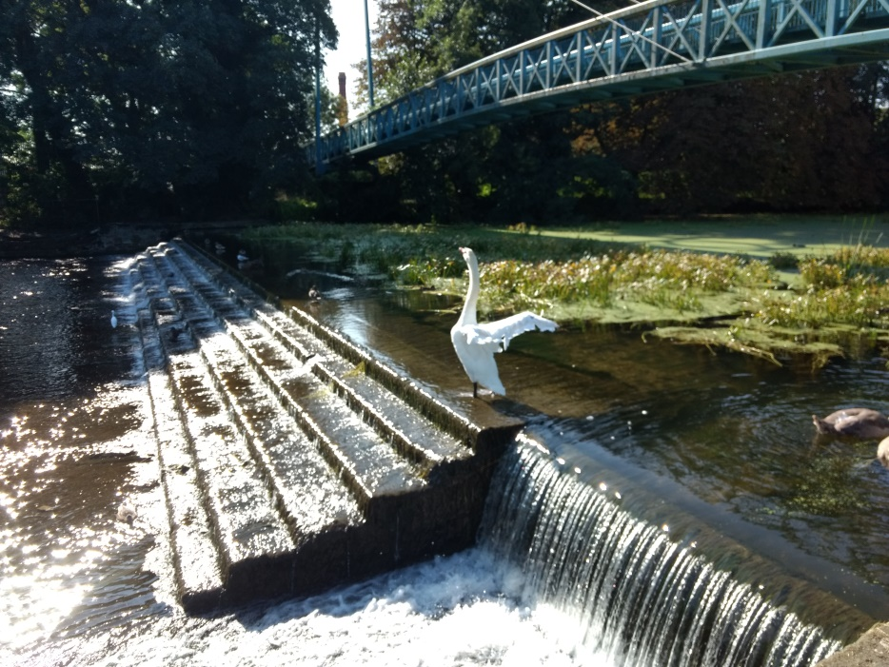 Photo by D Leeming

Jesus said:

“Whoever drinks the water that I will give him will never be thirsty again. The water that I will give him will become in him a spring which will provide him with life-giving water and give him eternal life.”

*John 4:14*

*Good News New Testament*

Helping needy children in India

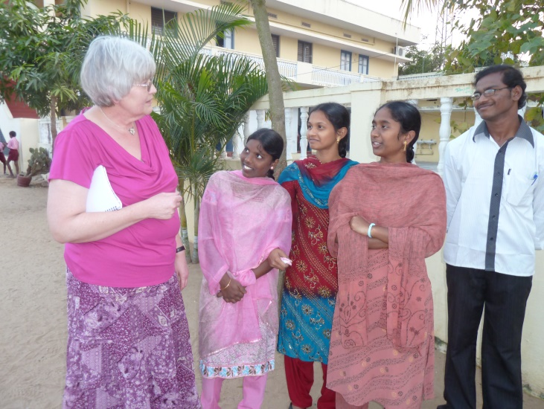

*Pauline Stanton-Saringer*

*describes a visit to*

*Andhra Pradesh to see homes*

*run by the Christiana*

*Children’s Homes Trust*

Just over 30 years ago, in Andhra Pradesh in India, a young lawyer*(Babu)* and his wife *(Hepsy)* began taking destitute children into their own family. The area where they live is mainly agricultural around a town called Bapatla. It is not a teeming city, but a poor area where tuberculosis and, increasingly, HIV Aids are bringing parents to an early death leaving orphans or one-parent families. The need is there and their Christian hearts are large.

Today, Christiana Children’s Homes Trust have two sites – one just outside Bapatla and one 40 miles away in Nidamarru. Together they care for about 230 children aged 5-18. They are happy places where food, clothing, shelter and education is provided in a caring, disciplined, Christian environment. I am a trustee of a small UK charity which began fundraising for the Homes in 2005 when their previous funding dried up. Since then I have visited every year but one. This year we (3 trustees and my husband!) went out for a week in late January/early February.

It is a long journey: 9-hour flight to Delhi, 2.5-hour flight on to Chennai then 5.5-hour train journey north to Bapatla. We arrive at about 8pm in the dark and, as we drive down the road to the Home, a sea of expectant faces appears in the headlights and we get an enthusiastic welcome. Everyone wants to shake hands and say ”Welcome Sister” and “How are you, Sister?” I love the flower garlands we are greeted with and only sorry that they will not last to bring home.

Immediately a welcome cup of tea appears and we begin to catch up news with Babu, Hepsy and the lovely people involved in running the home. Then Hepsy insists that we have a full cooked supper -in fact we really have to be politely firm with Hepsy to prevent her from overfeeding us during our stay.

Much of our time during the week is spent in meetings to get a feel of how things are going: education, welfare, finance and health. One of the trustees is a GP who gives up some of his annual leave to come each year – the rest of us are now retired! We visit the school attached to the home where our children and about 90 of the local poorer children are educated up to age 16 and our GCSE equivalent. This school was built in the late 1980s with money raised in the UK by a Christian doctor who was a missionary in Nepal but heard about the need in Bapatla.

We also have a day trip to the home in Nidamarru where we spend time with the 70 children there. They like to play games and the girls try to get me to skip and play dodge ball while the boys entice the men to wield a cricket bat! The children here attend a government school which is conveniently just across the road. The drive home as it gets dark can be exciting! It is best just to close your eyes as the driver overtakes or we meet a heavy laden ox cart travelling the wrong way down the dual carriageway!

Of course, we try to spend as much time as possible with the children, but their days are very full.

First bell at 5am; 6-7am study; breakfast and “chores”; 8.45 off to school 9-1pm. Back for lunch then school 2-4 or 5pm; snacks, one-hour leisure time, 6-7pm study; supper, prayers and bed (or more study.)

There is free time at the weekend. On Sunday morning the youngest go to a local Lutheran church for Sunday school while everyone else meets in the Prayer Room for a service in Teligu. It is very moving to see the older children leading the singing, reading the Bible passage and leading extempore prayer. If one of us is asked to give the talk, someone translates as we go along.

Gradually, the level of English is improving and the school now aims to teach in English, but we need some more teachers with really fluent English.

Across India, English is fast becoming the common second language. This is being promoted by the Government, it is not a hang-over from the British Raj! Babu is keen to give the children the best chance of being employable in the modern India.

The homes are run by Christian staff, and parents or guardians of the children taken in know there will be Christian worship. However, children from any religious background are accepted.

The Bapatla area has a higher than average Christian population and the Lutheran and Pentecostal churches and the Salvation Army are active in the area. These are all represented on the board of Indian Trustees of the homes.

Indian regulations do not allow direct evangelism in the homes, but no one has yet complained about the worship. We do notice that under the present government there is increasing suspicion of Christians coming to India from abroad. Three years ago, our treasurer- travelling with 3 other trustees- arrived in Chennai and was refused entry and put on the next flight back to the UK: a frightening and mortifying experience. The official would only say “visa irregularity”, but the Indian High Commission in UK said she held “a perfectly valid visa”. The others in the party were quizzed about why they were there and whether they prayed, but they were admitted.

We now fly into Delhi so that we go through immigration there before going on to Chennai. We stay one night in a hotel so that we can give that address on our visa application. We also pray hard before travelling and while we are there.

People ask me: “Is there still a need for residential homes for orphans and very poor children?” Babu himself and we trustees have asked ourselves the same question. Some outside charities advocate giving money to a child's remaining parent or guardian to help look after them at home. This has the problem of being unable to ensure that the money given is indeed used for the welfare of the child.

The sheer size of the population in India means that there can be no immediate “magic fix” for the problem of poverty. Much is being done to improve health and education. There are food subsidies for the poorest people. However, there is a widening gap between them and the wealthy middle class. Sadly, there does not seem to be the same culture of giving that we find in this country. This needs to be changed, but, in the meantime we cannot just say we are not going to help vulnerable children in India. We have experienced God's working in what we aim to do: bringing in the money we need; supplying the people we need to come to India to help; keeping everyone safe in our travelling. Our youngsters are being given hope for a better future and we are privileged to be able to help in some small way.

*The charity of which Pauline is a trustee is* ***C****hildren’s* ***H****omes in* ***I****ndia* ***T****rust (****CHIT****)* [*www.chitonline.org.uk*](http://www.chitonline.org.uk)

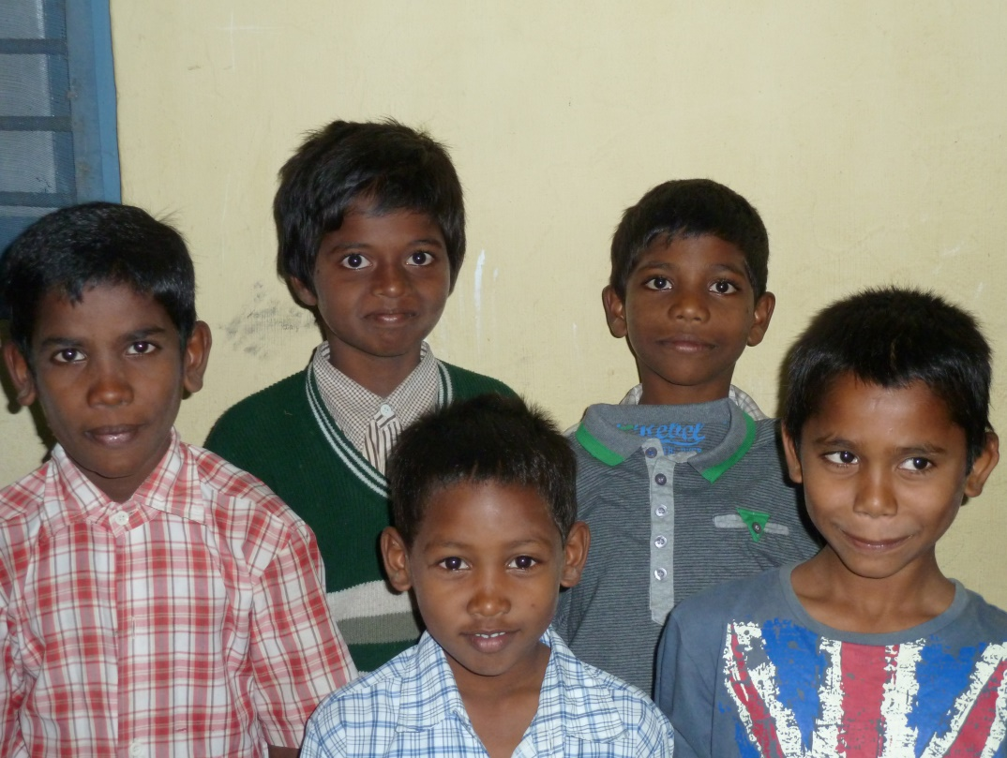

Christ is counting on You!

……..and I on Him!

Dates for your diary

**AGM and Ultreya**

Sat October 27, 2018

at Cumnor

**National Ultreya 2019**

August 31, 2019

at Chester

**Cursillo Weekend**

**Oxford#19**

Date May 16 – 19, 2019 at Cold Ash

near Newbury, Berkshire

**Cursillo Leaders’ Workshops**

**March 22– 24, 2019 at** Wistaston Hall, Crewe

**July 5 – 7, 2019** Shallowford House,

Stone, Near Stafford

**November 15 – 17, 2019 at** Diocesan Retreat House, Pleshey, Chelsmford

**Further information from:**

**CLW Administrator** Mr Paul Thacker

Chapel Cottage, 79 Chedburgh Road, Chevington,

Bury St Edmunds IP29 5 QU Tel 01284 850384

E-mail: [admin@anglicancursillo.co.uk](mailto:admin@anglicancursillo.co.uk)

**CLW Convenor** Rev Dr Judy Craig Peck

The Vicarage, 15, Church Mount, Guilsborough,

Northants. NN6 8QA Tel 01933 665965

E-mail: clw@anglicancursillo.co.uk

**Thank you to everyone who has contributed to this issue of OxonFourth.**

**The next issue is planned for the Spring and items for inclusion should be sent to:**

[***magazine.editor@oxfordcursillo.co.uk***](mailto:magazine.editor@oxfordcursillo.co.uk) ***to arrive* not later than March 15th, 2019.**

**Please contact me with ideas for articles well before this date.**

**Telephone 01296655342**

Oxford Anglican Cursillo is faith funded, so thank you to the increasing number of Cursillistas who support Oxford Anglican Cursillo through Gift Aid donations, particularly by monthly standing order. Under Gift Aid, each £1 donated is worth £1.25 to Oxford Anglican Cursillo, the extra 25p coming courtesy of HM Revenue and Customs.

If you would like to start making monthly donations, please contact the Treasurer at treasurer@oxfordcursillo.co.uk

**OxonFourth is published by Oxford Anglican Cursillo.**

**The views, opinions and statements expressed in OxonFourth**

**are those of the contributor and do not necessarily reflect opinions**

**or policies of the Editor or Oxford Anglican Cursillo.**